Drawing Shapes

1. The task is optional. If you complete the task, you can get from 1 to 5 points.
2. Select at least five different figures from the collection below. Try to choose not only figures that are easier, but also more difficult to draw.

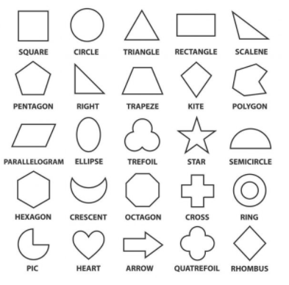

1. Using the Turtle library for Python (https://docs.python.org/3/library/turtle.html), create a program that draws the selected figures, at least four times each (20 figures minimum to be drawn). Arrange the figures on the plane in an interesting way. You can draw them in rows, columns, random positions, etc. You can even create an interesting picture that consists of selected figures. Make the figures more attractive by using different figure line colors, background colors, sizes, etc. Just be creative.
2. Define a class that describes the drawing being created. Put in the class:
   1. methods for drawing figures with parameters that allow to determine the position of the figure, its size and color
   2. a method for drawing a resulting picture comprising selected figures
   3. a method for writing your name, surname and your full group number in the upper right corner of the resulting picture
   4. other methods that may help you with completing the task
3. Based on the defined class, create an object and invoke a method for drawing a resulting picture and your personal data in the upper right corner.
4. Submit to the Moodle for assessment:
   1. A program code with the name NameSurname.py (e.g. AnnaMay.py)
   2. An resulting image in jpg or png format with the name: NameSurname.jpg/png (e.g. AnnaMay.png).